With age.
Took me pretty long to run all the glmer models again at home, took even longer with an extra variable. After adding age as an extra variable, all hind models have the lowest AIC, and are also mostly significant and in the right direction.
Summary
Yellow = insignificant
 | glmer | glmmTMB | glmer  No Birthwt | glmmTMB  No Birthwt
Hinds | -0.484 (p=1.06e-14) | -0.920 (p=1.06e-13) | -0.173 (p=0.428) | -0.223 (p=0.0273)
Adults | 0.0102 (p=7.10e-13) | -0.227 (p=0.199) | 0.155 (p<2e-16) | -0.231 (p=0.0166)
Total | -0.114 (p=0.593) | -0.584 (p=0.094) | 0.104 (p<2e-16) | -0.1997 (p=0.0203)
LU_Total | 0.0535 (p=0.933) | -0.223 (p=0.0273) | 0.191 (p<2e-16) | -0.504 (p=0.316)
AIC
 | glmer | glmmTMB | glmer  No Birthwt | glmmTMB  No Birthwt
Hinds | 510.6 | 491.4 | 1526.4 | 1466.8
Adults | 523.4 | 502.4 | 1532.9 | 1470.0
Total | 520.0 | 497.9 | 1532.6 | 1470.7
LU_Total | 524.0 | 503.0 | 1531.0 | 1471.7
Scaled (Yellow = insignificant)
 | glmer | glmmTMB | glmer  No Birthwt | glmmTMB  No Birthwt
Hinds | -11.4 (p=0.00011) | -25.16 (p<2e-16) | -4.85 (p<2e-16) | -5.18 (p=0.0274)
Adults | -4.01 (p=0.503) | -6.97 (p=0.215) | -3.11 (p=0.281) | -7.09 (p=0.0168)
Total | -6.122 (p=0.0796) | -13.82 (p=0.00074) | -2.31 (p=0.410) | -6.84 (p=0.0204)
LU_Total | -2.195 (p=0.552) | -22.51 (p=0.0944) | 0.796 (p=0.913) | -6.08 (p=0.317)
Scaled AIC
 | glmer | glmmTMB | glmer  No Birthwt | glmmTMB  No Birthwt
Hinds | 511.8 | 494.2 | 1520.3 | 1466.8
Adults | 520.7 | 502.4 | 1528.7 | 1470.0
Total | 522.4 | 501.6 | 1529.3 | 1470.7
LU_Total | 520.2 | 503.0 | 1530.5 | 1471.7

glmmTMB
Hinds
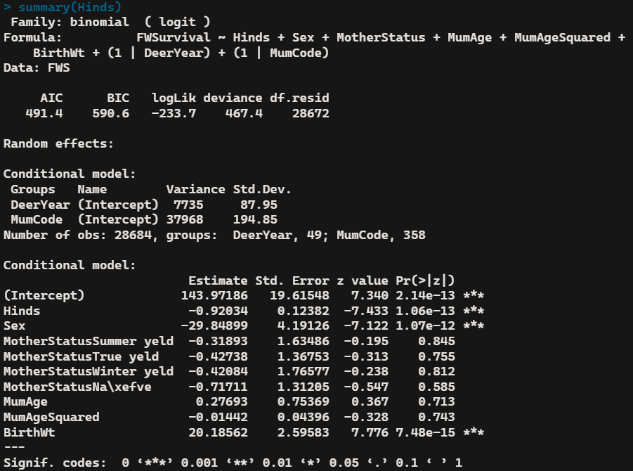
Adults
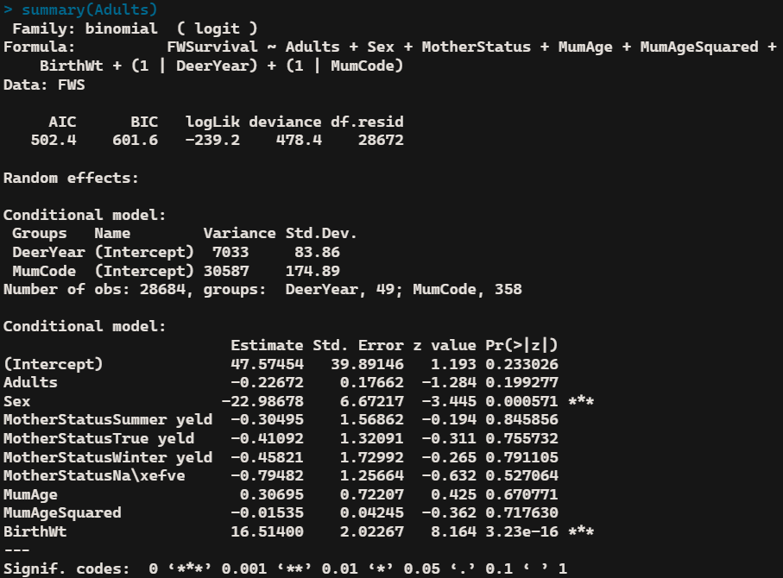

Total
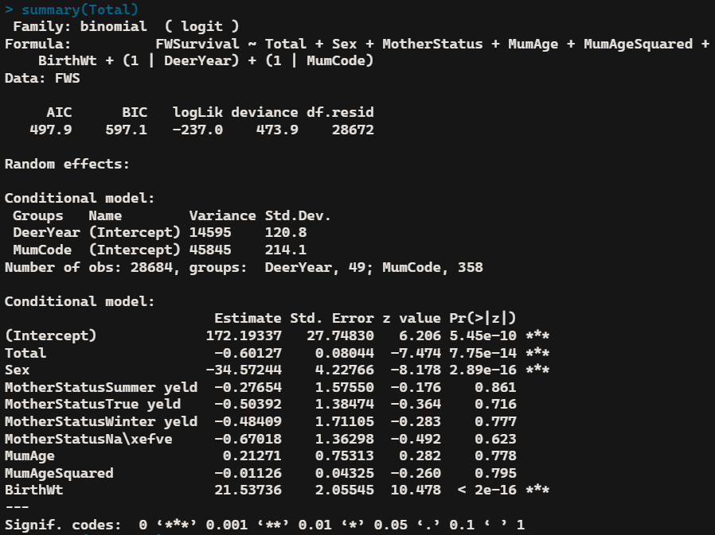
Livestock Units
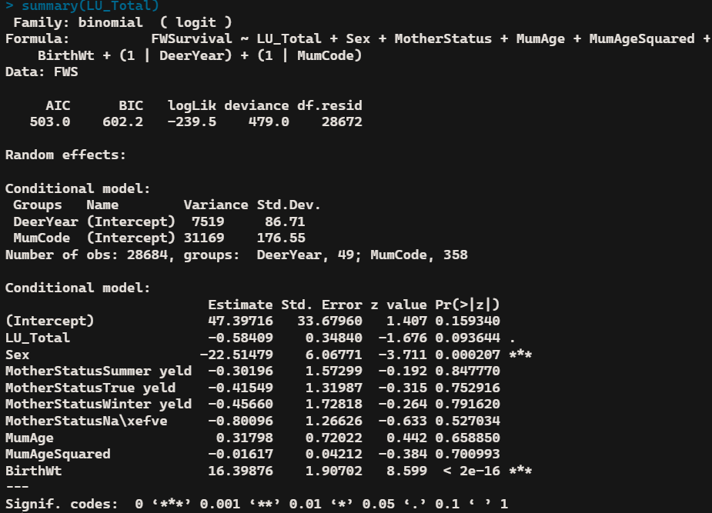

glmmTMB
Hinds w/o birth weight
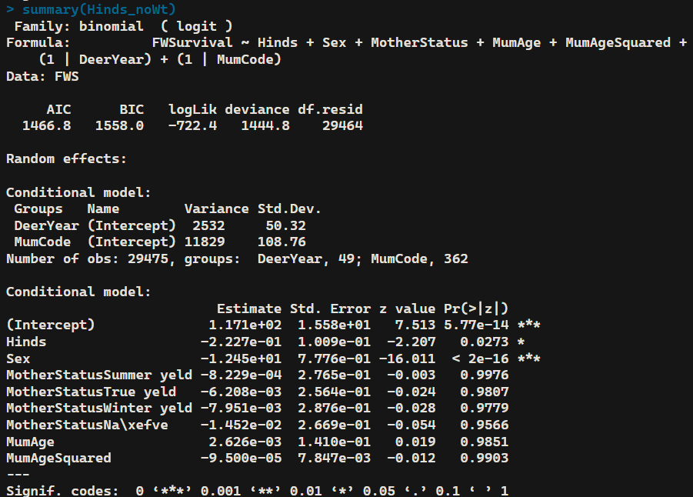
Adults w/o birth weight
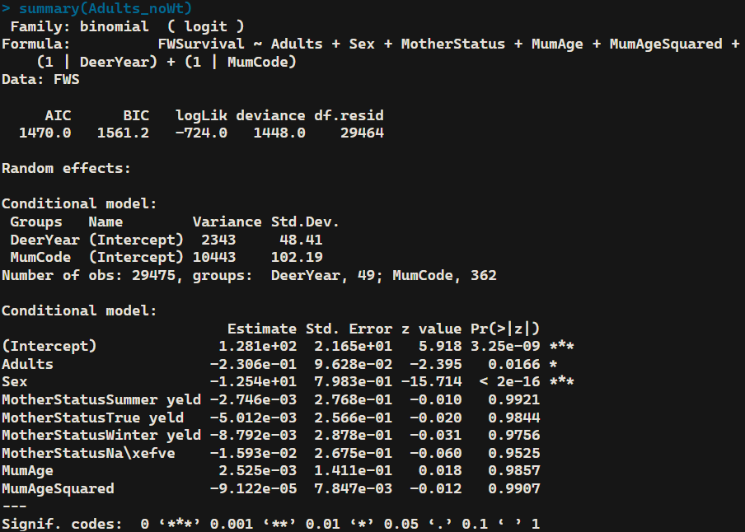

Total w/o birth weight
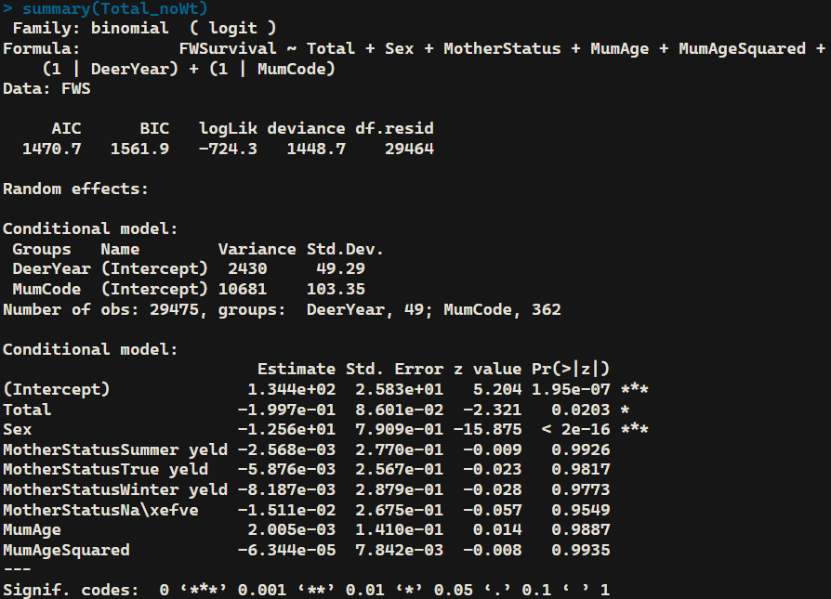
Livestock Units w/o birth weight
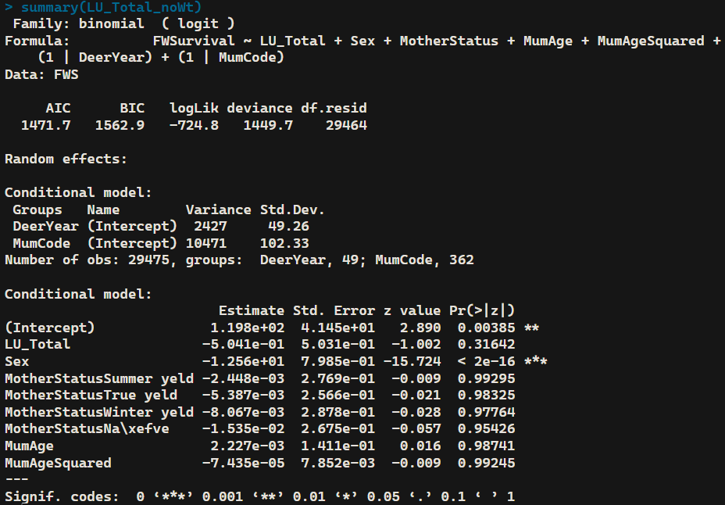

glmmTMB
Scaled Hinds
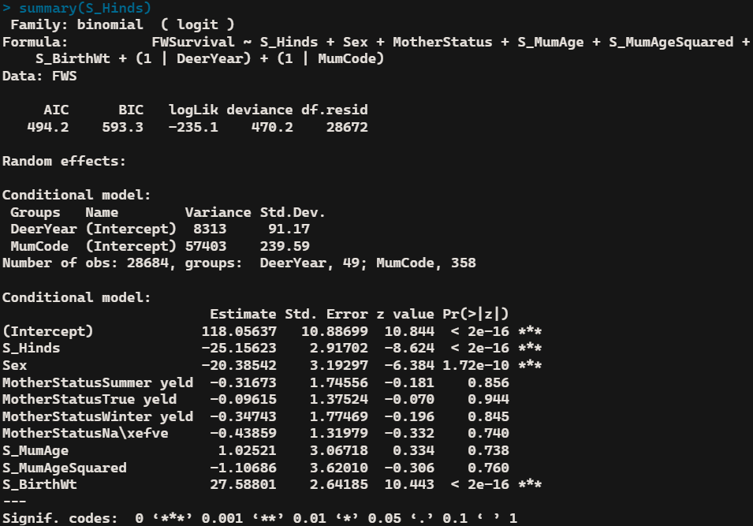
Scaled Adults
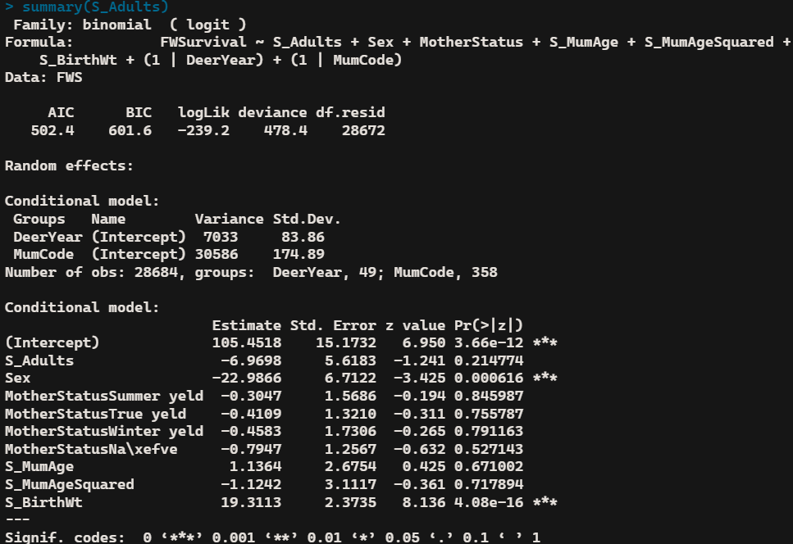

Scaled Total
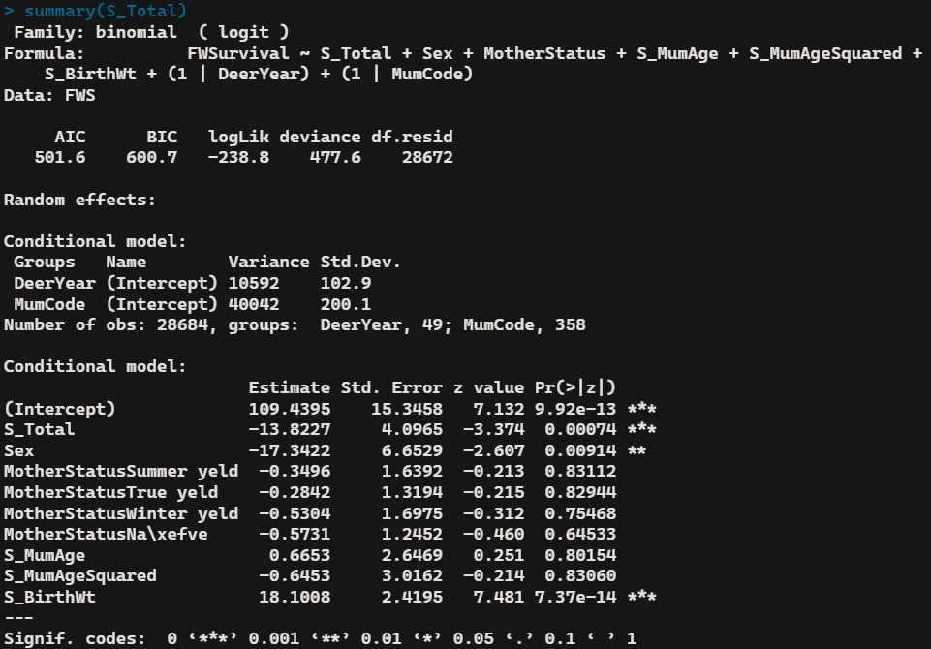
Scaled Livestock Units
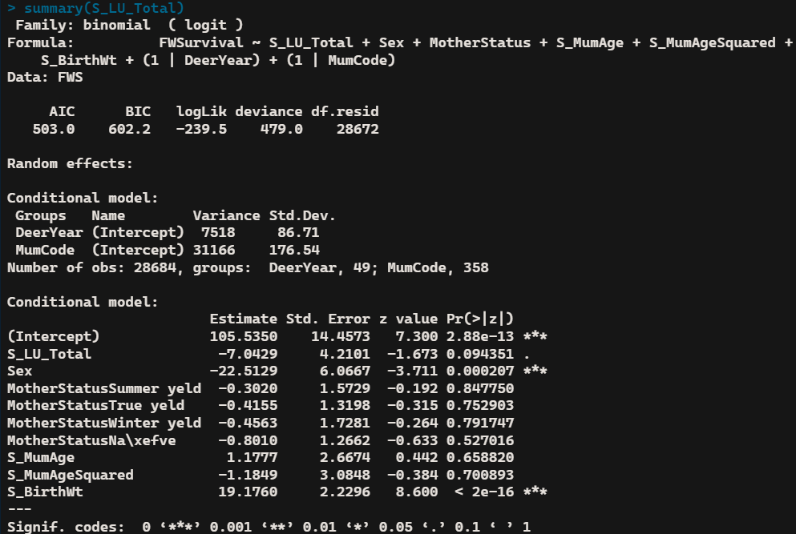

glmmTMB
Scaled Hinds w/o birth weight
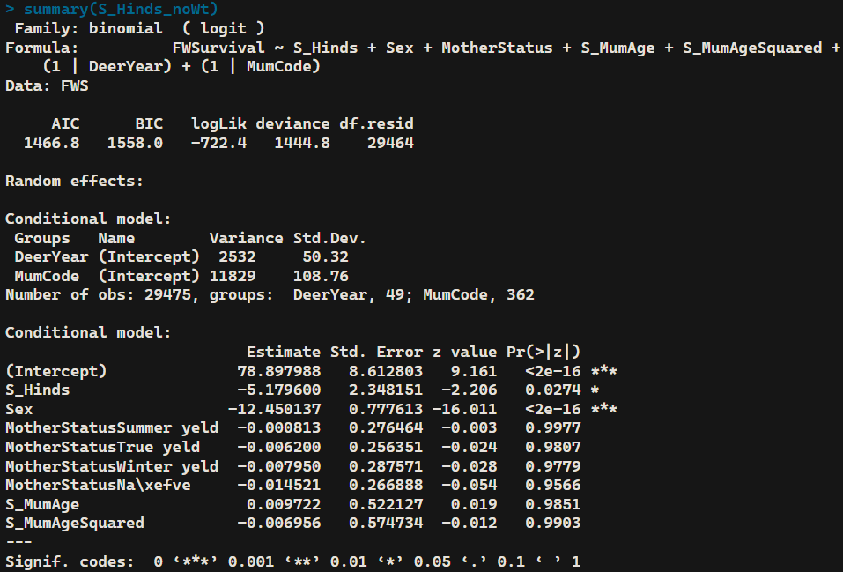
Scaled Adults w/o birth weight
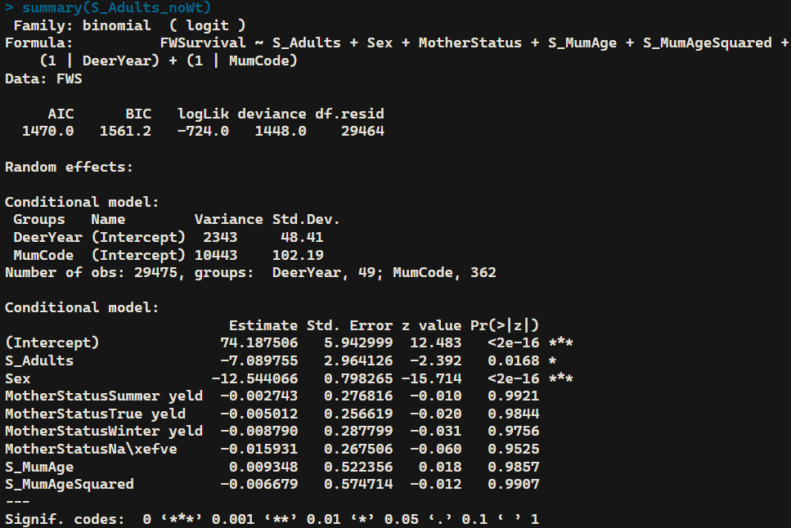

Scaled Total w/o birth weight
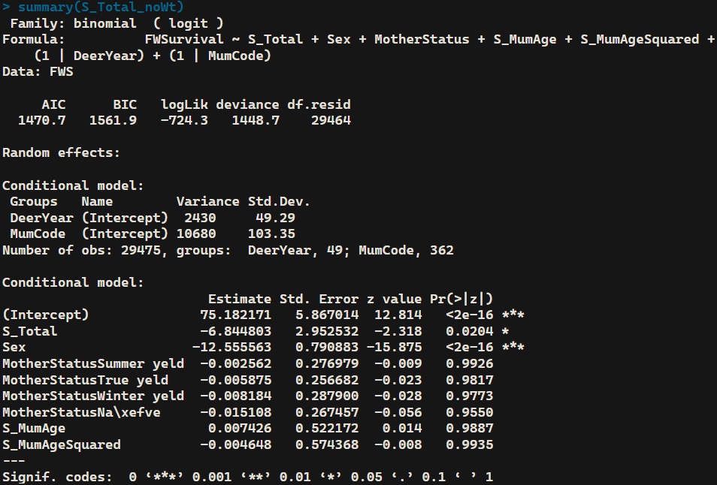
Scaled Livestock Units w/o birth weight
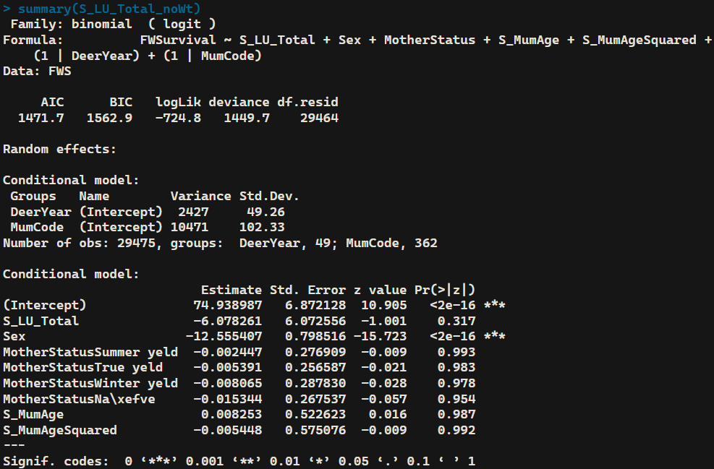

glmer
Hinds
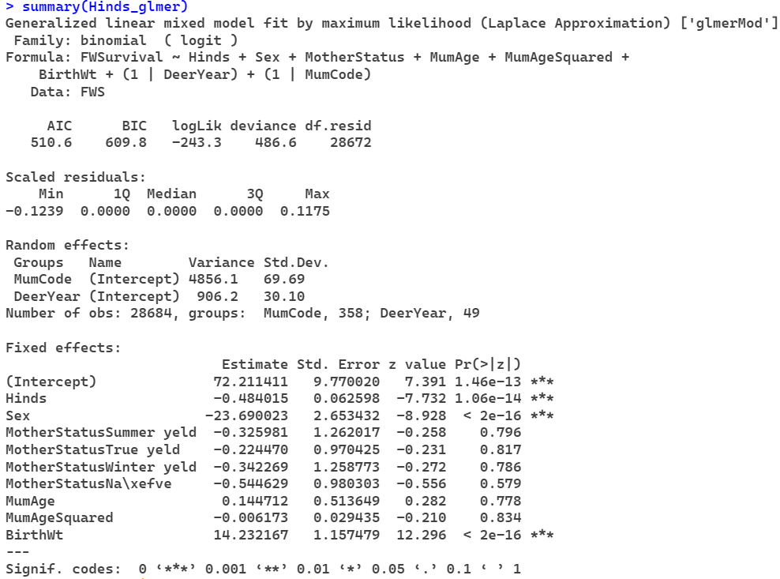
Adults
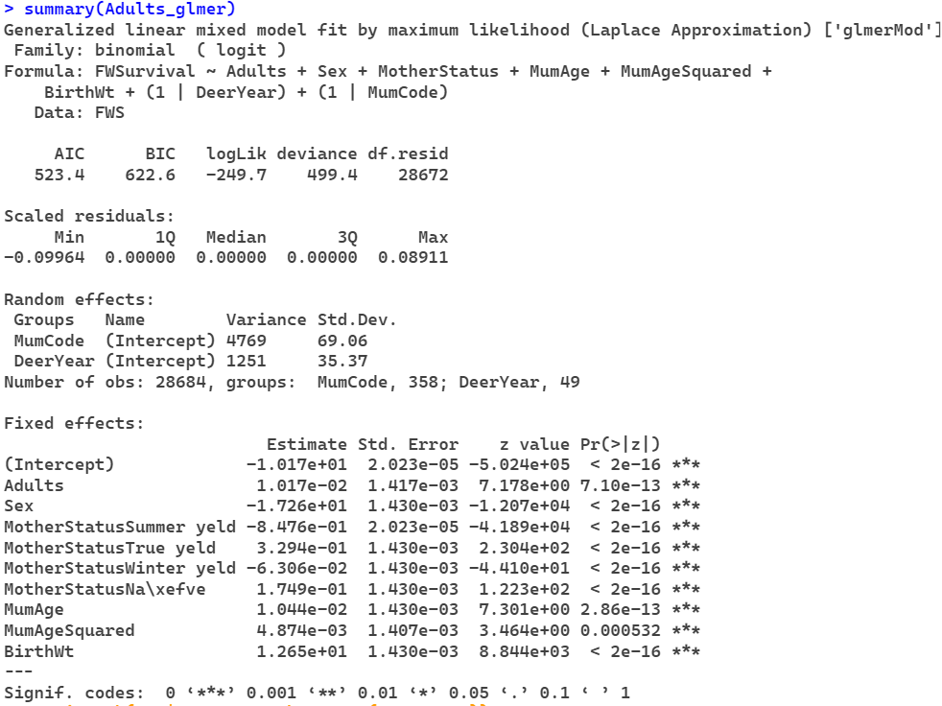
Total
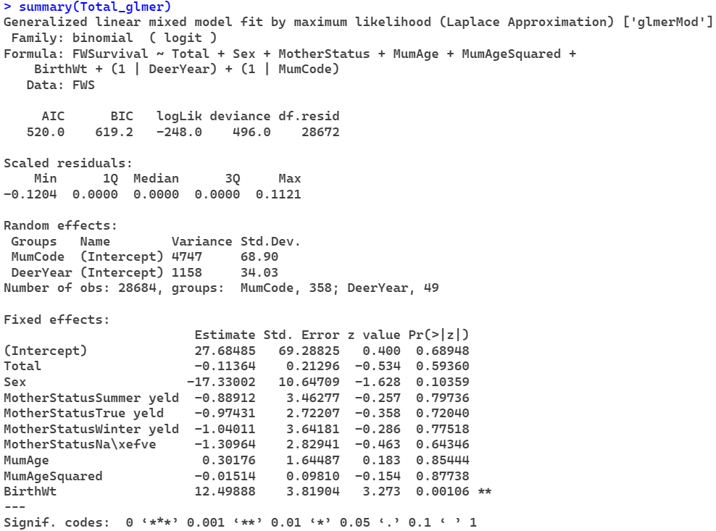
Livestock Units
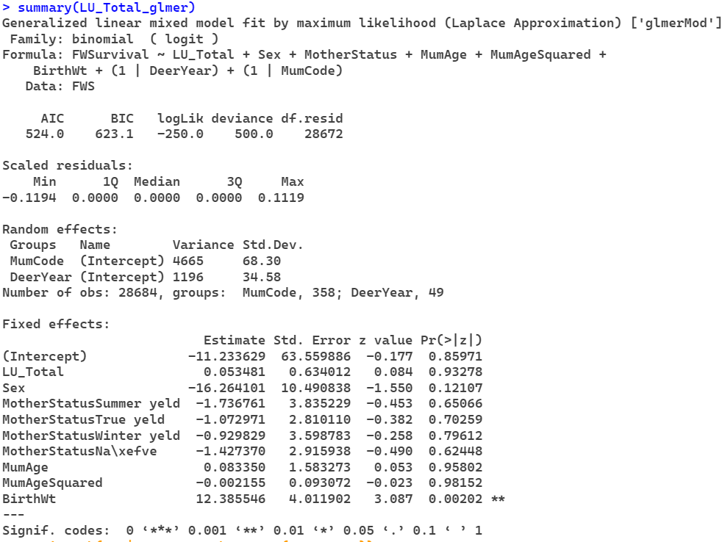

glmer
Hinds w/o birth weight
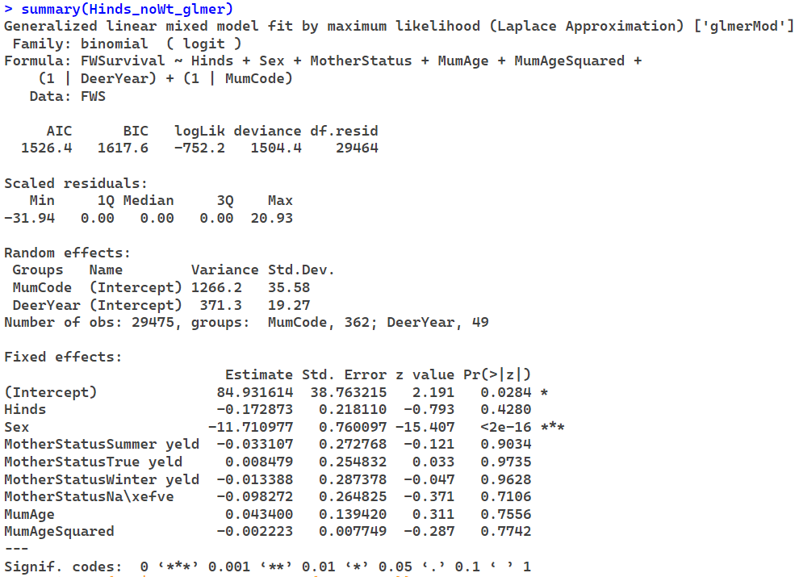
Adults w/o birth weight
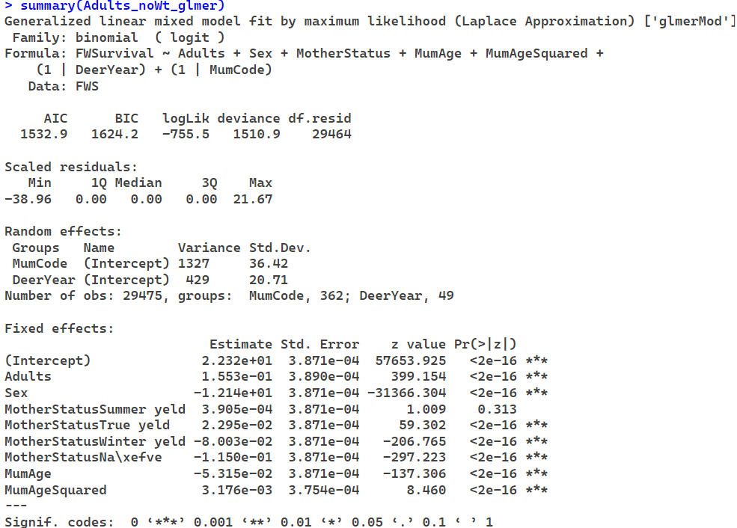

Total w/o birth weight
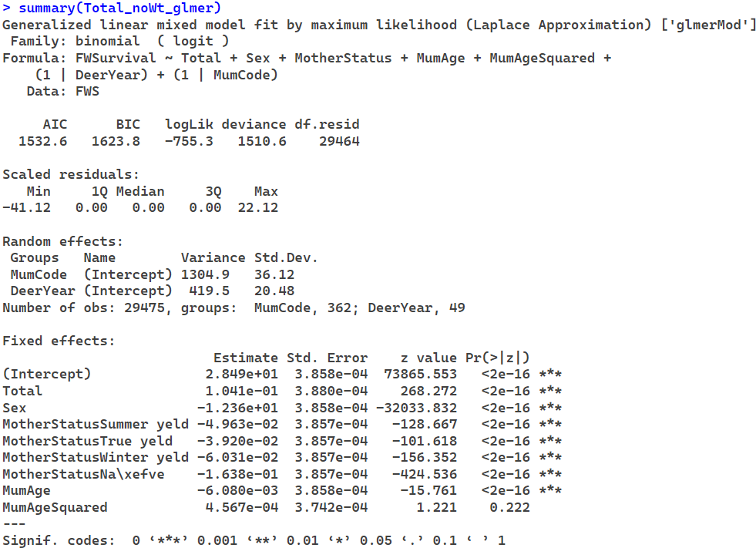
Livestock Units w/o birth weight
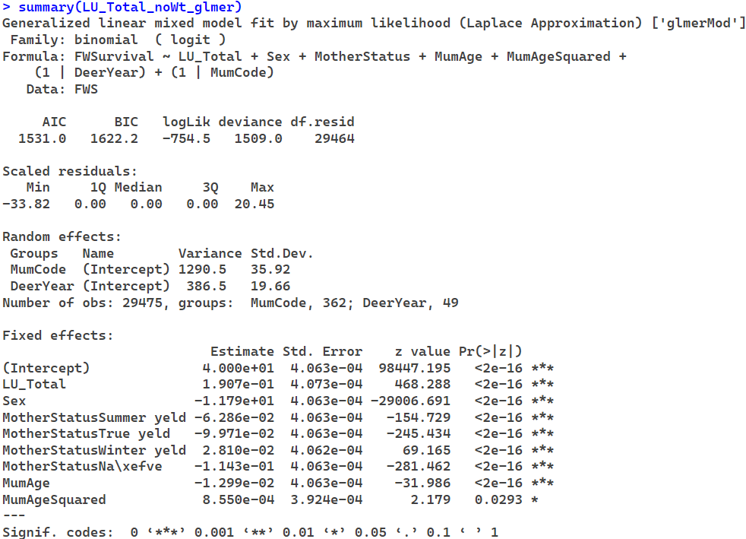

glmer
Scaled Hinds
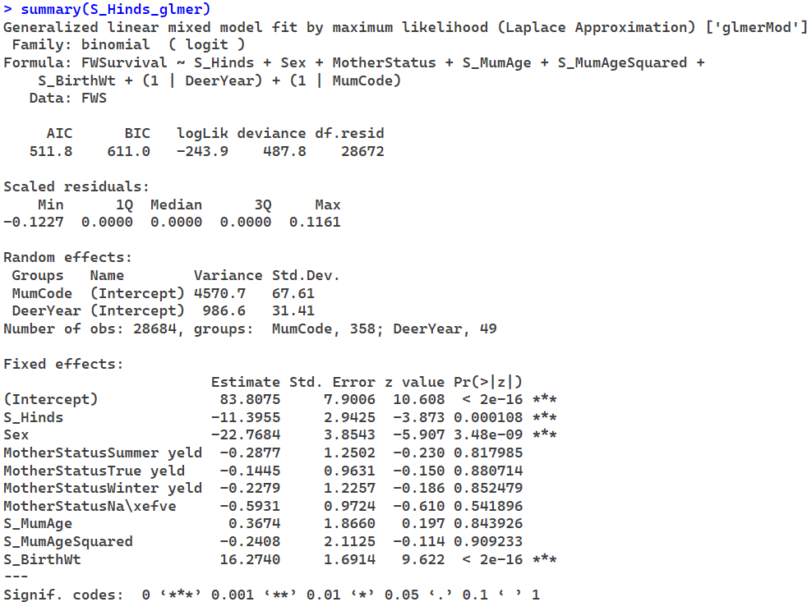
Scaled Adults
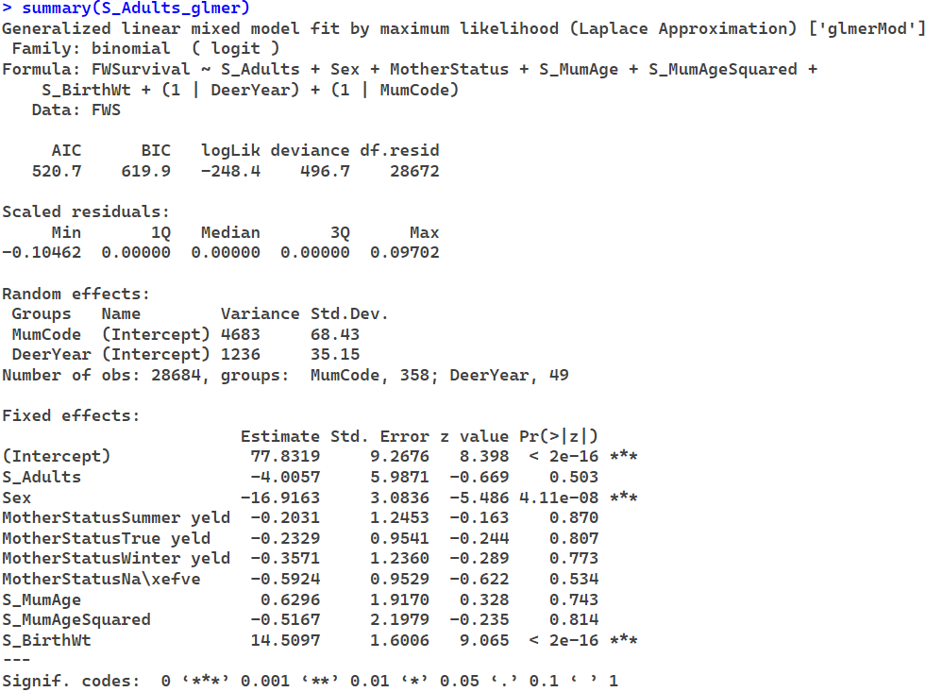
Scaled Total
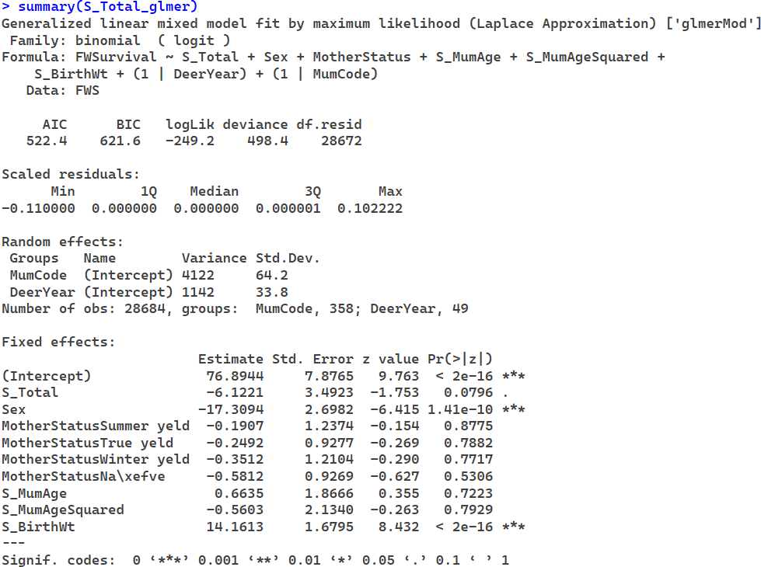
Scaled Livestock Units
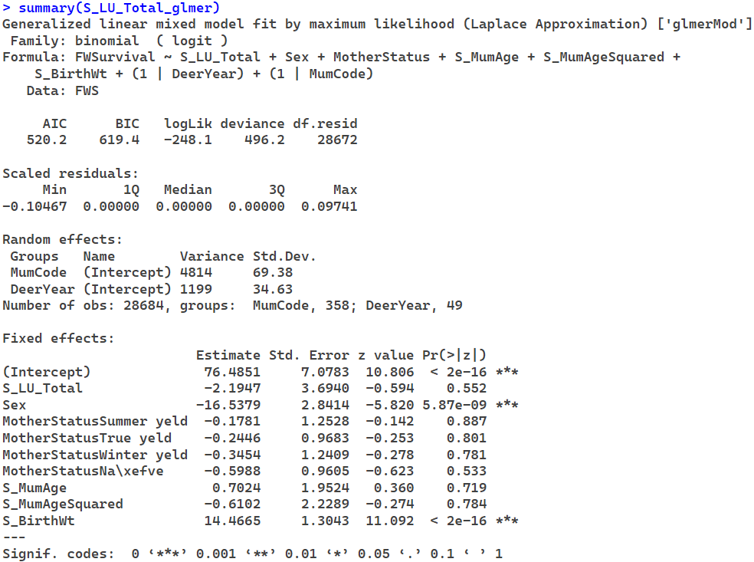

glmer
Scaled Hinds w/o birth weight
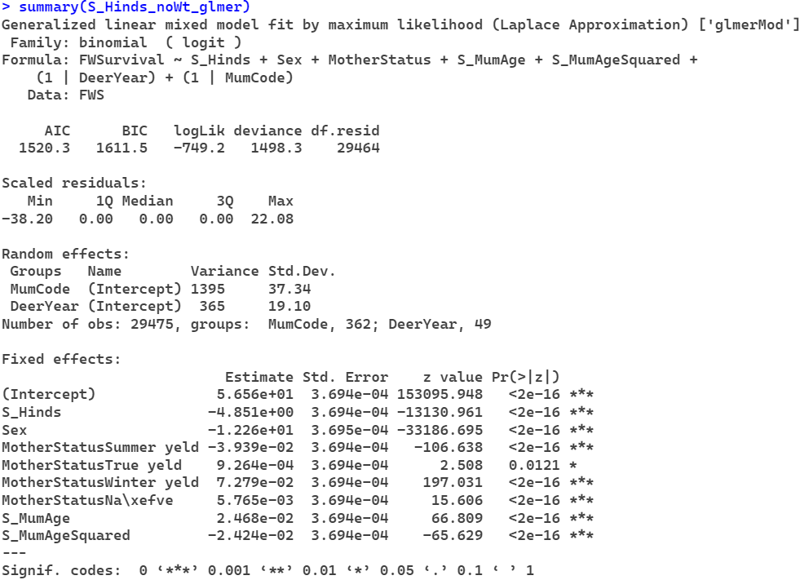
Scaled Adults w/o birth weight
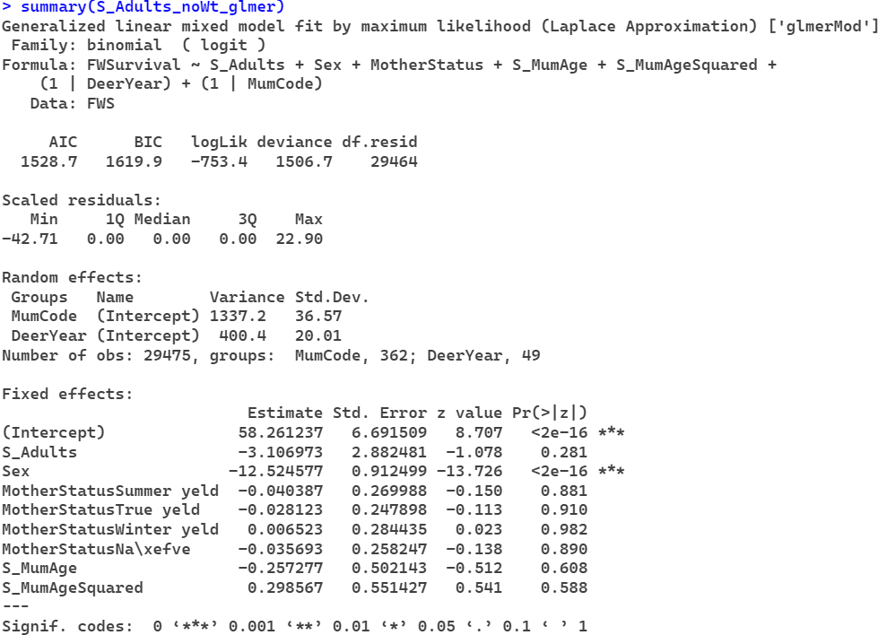

Scaled Total w/o birth weight
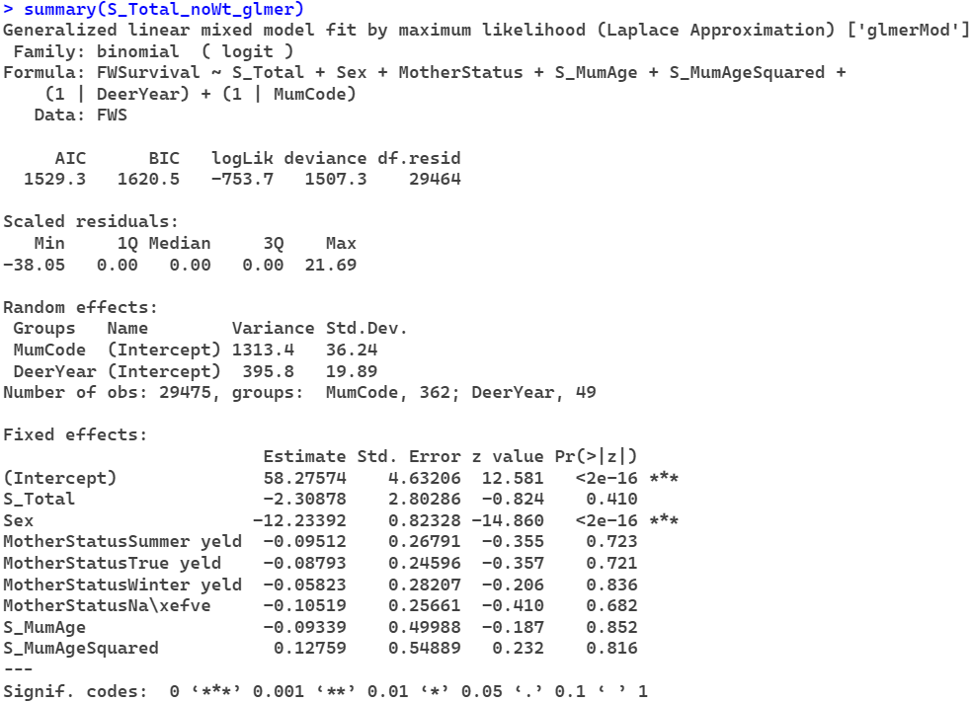
Scaled Livestock Units w/o birth weight
